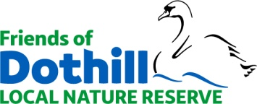 MEMBERSHIP FORM

I wish to join the Friends of Dothill Local Nature Reserve (FDLNR).

PLEASE PRINT CLEARLY

Title: ................ First Name: ......................................................................

Surname: ...................................................................................................

I confirm that I am over 18 years of age. (Tick box):

(Under 18s must provide date of birth for insurance purposes)…………………………

Address: ....................................................................................................

...................................................................................................................

Contact phone number: ............................................................................

Email: ........................................................................................................

I am happy to be contacted by email by phone by post with information from FDLNR.

Signed: ............................................................. Date: ..............................

DATA PROTECTION: Your details will only be used for membership administration purposes within the FDLNR group and will not be shared externally with any third party.

Please tick the appropriate box(es):

I wish to be involved in activities

I would be happy to help with publicity/fundraising

Please complete and email to fdlnr.membership@gmail.com

Thank you! [August 2021]

